**Harsh Vardhan Kushwaha**

**17BCN7017**

**PL SQL Assignment 1**

1. **Write a PL/SQL block to accept an empno and display the salary of the person.**

Code –

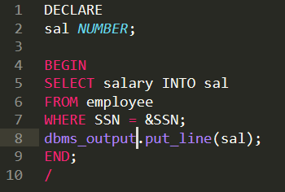

Execution –

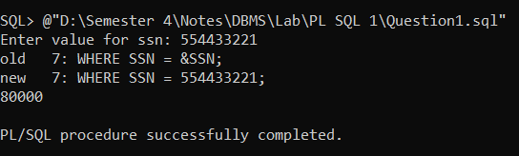

1. **Write a PL/SQL program to delete one record in employee table.**

Code –

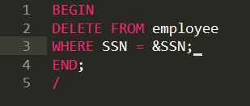

Execution –

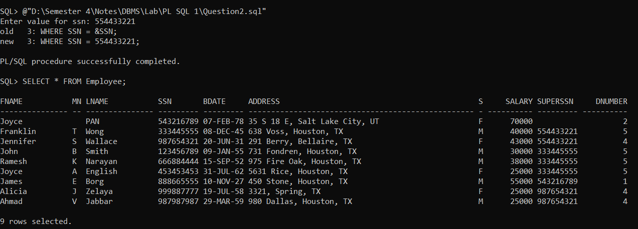

1. **Write a program to delete employee details who are having age > 60.**

Code –

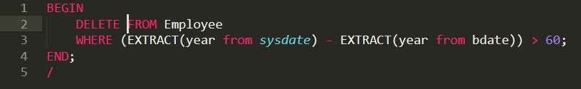

Execution –

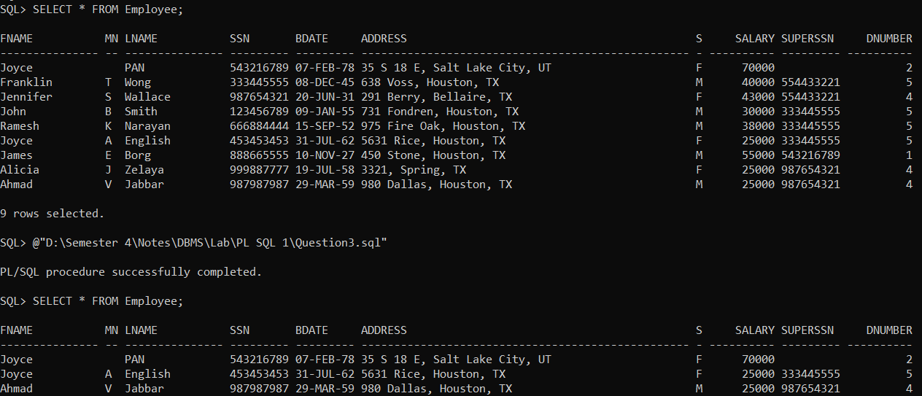

1. **Write a PL/SQL block to display employees must make a minimum salary of 60,000.**

Code –

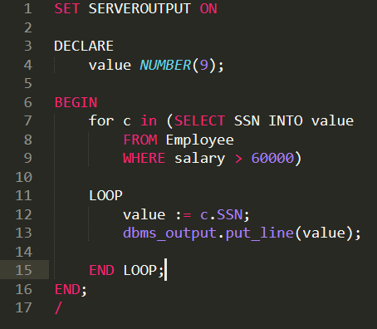

Execution –

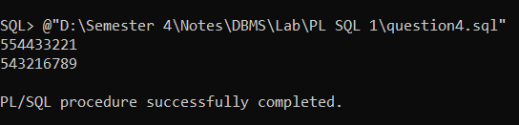

1. **Write a PL/SQL to delete records whose basic salary is less 5000 from Emp table.**

Code –

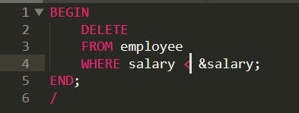

Execution –

